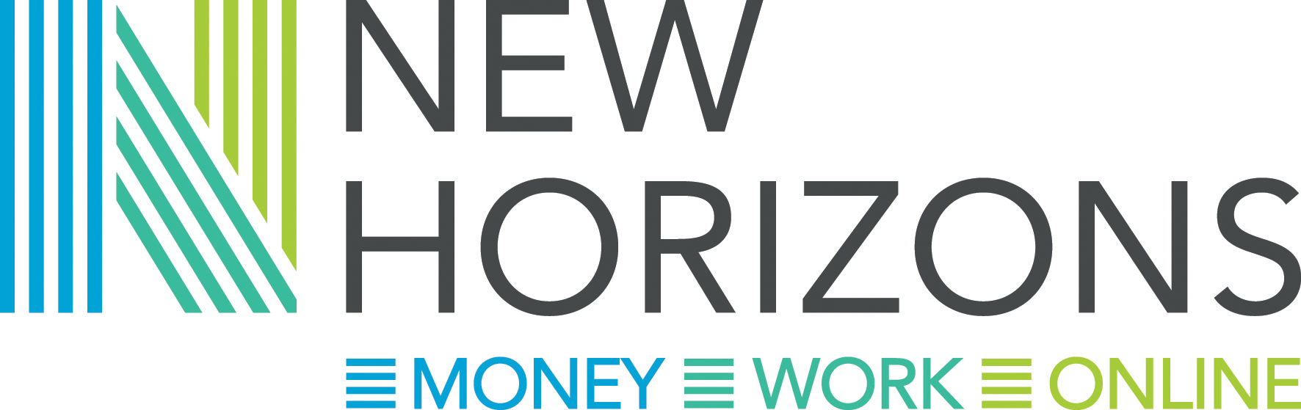

Managing the challenges beyond money
Free frontline worker conference
13th November 2018: 9.30-4pm Burgess Hall, St Ives
(Lunch and refreshments included)

You are very welcome to our New Horizons conference on 13th November at the Burgess Hall in St Ives, which continues the highly successful Making Money Count series. It is for anyone working or volunteering with people facing money challenges, perhaps as a result of benefits changes or those managing on a low income. The workshops recognise the complexity of front line work and offer a wide range of professional development opportunities. We will also have information stands showcasing local organisations.
If you are a volunteer or paid worker in Cambridgeshire, Peterborough or Kings Lynn (and the surrounding areas) you will find this event very useful – speakers are from a range of national and local organisations and all workshops will be practical, giving lots of opportunities to ask questions and reflect on your own experience and practice.
To book a place please complete your details below and indicate your workshop choices on the next page. All places will be allocated on a first come first served basis – our last three conferences were very popular so do book quickly.

Yes, I would like to join you on 13th November from 9.30 – 4pm
Name: | Organisation:
Email: | Phone:

Do you have any access or dietary needs that we should be aware of? YES/NO

FINISH YOUR BOOKING BY COMPLETING THE WORKSHOP REQUEST FORM OVERLEAF

Workshops will be running in three sessions. Please look at the choices below and put them in order of preference from 1 to 4 for each session block (where 1 is your first choice).
Session title | Description
Session one – Understanding your ways of working
An Introduction to Motivational Interviewing | An introduction to Motivational Interviewing. You will learn the fundamentals of a motivational skills approach and how these can usefully frame early help conversations and transform difficult conversations.
Mindfulness | Is Mindfulness just a fad or can it be used to effect real change? This session will help you understand what mindfulness is and how you can use it in a simple way in your day to day work to achieve better outcomes for yourself and the people you are working with.
Keeping the focus; working with people with complex needs | How do we best work in a focused way with people who have complex lives and needs? How do we avoid creating dependency and enable people to move on from our support?
What’s good for us? What’s good for our clients? | Using practical examples this session will help you explore how you can extend your wellbeing and respond more effectively when facing challenging situations using strength based techniques.
Session two – complicated lives, understanding the needs of the people you work with
Understanding vulnerability | This session will explore models for identifying and working with vulnerability and how these can help in prioritising and designing services. Sharing practical tools and first-hand experience from the new national fuel poverty service delivered by Clarion Futures
Homelessness prevention – what works and what is available | Exploring learning from the Homelessness trailblazer project running across the County, with an opportunity to discuss best practice, other services available and ways of working together to tackle homelessness more effectively in Cambridgeshire
Mental Health First Aid (MHFA), an introduction | MHFA is a nationally recognised training course. This session explores the challenges you may face and how you can work appropriately, assertively and safely, including tips on how to respond to someone in a mental health crisis.
Adapting your work for people with additional support needs | The Early Help Team and Learning Disability Partnership are leading this workshop on how to adapt your delivery to meet the needs of the people you are working with who have may a learning disability or cognitive impairment.
Session three – the changing landscape
Universal Credit, learning from experience | The session will give first hand insight into the experience of moving onto full digital service for Universal Credit claimants – the challenges, solutions and lessons learnt, form a Job Centre Plus and front line worker perspective.
Maximising Benefit Support | Ensuring that households are getting all of the welfare support they are entitled to is one of the main platforms for tackling poverty. How can non specialists best support the people they work with? Tools and tips on spotting gaps and supporting clients
Help in a crisis | An overview of the crisis grants available locally, including CLAS with hints and tips for making a successful application and where to get further information
Integrating support – sharing good practice from New Horizons | Cambridge University are providing an action research approach to the New Horizons project. Reflecting on the first two years of this project, what have we learnt about 121 coaching approaches to financial inclusion?

Email this form to new.horizons@chsgroup.org.uk by Sept 28th to book your place

