[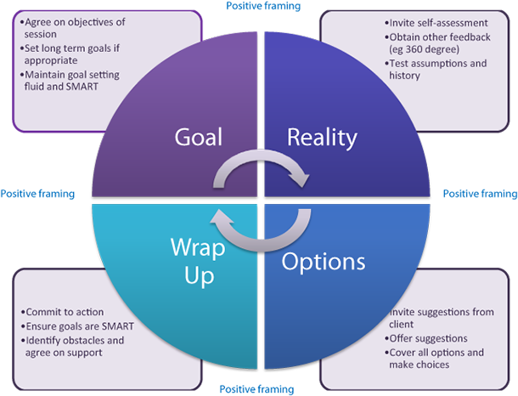](https://www.google.co.uk/url?sa=i&rct=j&q=&esrc=s&source=images&cd=&cad=rja&uact=8&ved=2ahUKEwjsguXP_J7eAhUEyaQKHQo9CkUQjRx6BAgBEAU&url=https://www.interaction-design.org/literature/article/the-grow-model-similarities-between-coaching-and-ux&psig=AOvVaw1t7r0-0I53SBcP-52hjMuk&ust=1540466872729286)